**EE 5110 Segment D**

**Stock Counting Unmanned Aerial Vehicles**

Guo Shiping

A0260014Y

**Assignment requirement**

Background:

Manual warehouse stock counting used to be a tiring, boring and sometimes dangerous job. A small-size unmanned aerial vehicle (UAV) equipped with sensors and smart software algorithms can be a very good solution to automate such a process.

Work Requirements:

Write a report to survey existing state-of-the-art hardware products and software methods and propose your own UAV system that an be used for such an autonomous stock counting task by considering the following mission requirements:

* Maximum take-off weight of the UAV: Less than 3 kg
* Autonomously fly and conduct stock counting for both left and right sides racks of a

warehouse aisle with the following specifications and the mission must be finished within one take-off flight without battery change:

Aislelength:80m  
Aislewidth:2.5m  
Aisleheight:8m(5layers of cargos with equally distributed layer heights)

Cargo information is encoded with in a barcode facing the aisle.

You should mainly focus on the following 3 topics for the considerations of the

system design:

1. Platform choice and component selection
2. Autonomous flight control
3. GPS-less navigation
4. Size: A4 portrait
5. Font: Times New Roman 11.5
6. Not more than 20 pages
7. Name your report as A1234567.pdf (where A1234567 is your matric number)

Submission:  
Upload to Canvas under Segment D submission folder before 5 November 2023, 23:59.  
*Note that plagiarism and copying are serious offences and students caught doing so will be  
reported to university. Late reports will also be penalized (10% per day).

**1. Introduction**

Manual stock counting in warehouses is labor-intensive and potentially hazardous. Small UAVs equipped with sensors and intelligent software have emerged as a promising solution to automate and streamline this process. This report surveys advanced hardware and software for autonomous stock counting and proposes an innovative UAV system design that leverages **computer vision** and **image processing** for robust and versatile counting and SLAM, providing a superior alternative to traditional methods. Additionally, I implement **central computing control** ideas for practical development.

**2. Stock Counting System Development.**

There are two widely used counting methods: RFID tags and code scanners[1]. In the inventory management process, some companies employ methods like counting with manlifts, baskets, and RFID tags to expedite the process. Others utilize robots, as shown in Figure 1, to automate barcode scanning. Today, UAVs offer another viable option to replace robots for this task.

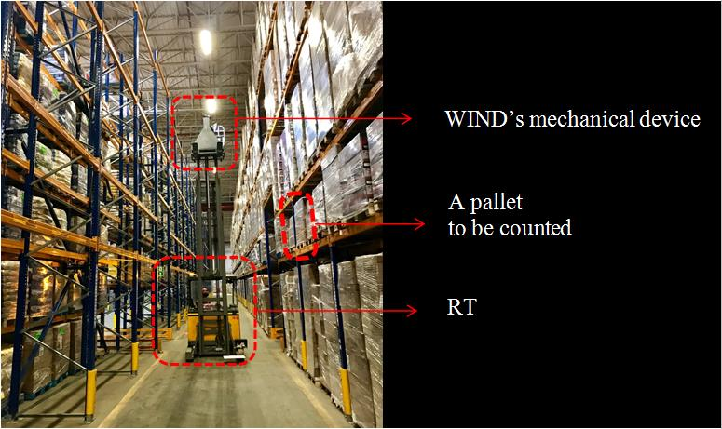

Figure 1 Semi-counting robot

**RFID tags:**

RFID tags must be attached to each product for systematic record-keeping [2]. While this method can increase inventory management costs, organizations with production and storage capabilities can offset these costs by including tag expenses in the product sale price. However, businesses solely focused on storage face additional costs, as each tag is assigned to a single product and cannot be reused. Accurate data recording for these tags also requires substantial investment due to metal-intensive warehouse environments with metal shelving.

**Code scanner:**

Similar to RFID tags, scanning and encoding precise information for different types of storage is convenient. However, some products may lack codes, necessitating the addition of codes manually, resulting in increased costs, much like RFID tags.

**3. Design criteria, objectives and priorities**

To design an effective autonomous stock counting UAV system, we must first consider the mission requirements outlined as follows:

Maximum Take-Off Weight

* The UAV's maximum take-off weight not exceed 3 kg.

Autonomous Operation

* The UAV should be capable of autonomous flight and stock counting within a warehouse aisle.
* Need a very high accuracy and speed.

Warehouse Aisle Specifications

* Aisle Length: 80 meters
* Aisle Width: 2.5 meters
* Aisle Height: 8 meters (comprising five equally distributed cargo layers)
* Cargo Information Encoded within Barcodes, facing the aisle

Based on these requirements, list the objective and priority of different Merits

Table 1 Objectives

|  |  |  |  |  |
| --- | --- | --- | --- | --- |
| No | Objective | Basis for measurement | Criterion | Units |
| 1 | High accuracy | The rate of accurate detection | Accurate rate |  |
| 2 | Faster image processing | Time to process one frame | Speed |  |
| 3 | Inexpensive in market | Unit manufacturing cost | Manufacturing cost | Dollar |
| 4 | Inexpensive in operation | Fuel consumption per km | Operating cost | Liter/km |
| 5 | Light weight | Total weight | Weight | N |
| 6 | Small size | Geometry | Dimensions | m |
| 7 | Medium | Speed of operation | Performance | m/min |
| 8 | Maintainable | Man-hour to maintain | Maintainability | Man-hour |
| 9 | Producible | Requirement for manufacturing | Manufacturability | - |
| 10 | Recyclable | Amount of hazardous or non-recyclable materials | Disposability | kg |
| 11 | Maneuverable | Turn radius; turn rate | Manoeuvrability | m |
| 12 | Detect and avoid | Navigation sensors | Guidance and control | - |
| 13 | Airworthiness | Safety standards | Safety | - |
| 14 | Autonomy | Autopilot complexity | Crashworthiness | - |

Table 2 Priority

|  |  |  |  |
| --- | --- | --- | --- |
| No | Figure of Merit | Priority | Target |
| 1 | Performance | 1 | High accuracy and fast processing speed |
| 2 | Autonomy | 2 | Run automatically |
| 3 | Cost | 3 | Low cost |
| 4 | Producibility | 4 | Can easily manufacture |
| 5 | Weight | 5 | Less than 3kg |
| 6 | Maintainability | 6 | Easy to maintenance |
| 7 | Period of design | 7 | Less than one year |
| 8 | Disposability | 8 | The less the better |
| 9 | Scariness | 9 | Have necessary protection |
| 10 | Stealth | 10 | Not required |

**4. Proposed Solution**

The two methods mentioned above have several key disadvantages:

1. Stock must be well-arranged and orderly.
2. The attachment of tags or codes to stock can result in higher costs.

For RFID tags, it is challenging to determine the specific position of stock.

For code scanners, hidden stock cannot be detected.

**4.1 Proposed solution for counting**

My proposed solution is based on computer vision technology, which has seen rapid development and widespread application in recent years. We can leverage this cutting-edge technology for inventory counting. The general concept is to train a model to detect stock items and use UAVs to capture images of the inventory. We can draw inspiration from similar applications, such as 'Object Detection using Hybrid Learning based on Multi Scale Dilated Convolution Module Mechanism' [3]. This article focuses on addressing the mentioned challenge and presents a viable method to use vehicle detection outcomes for tracking multiple objects and counting vehicles.

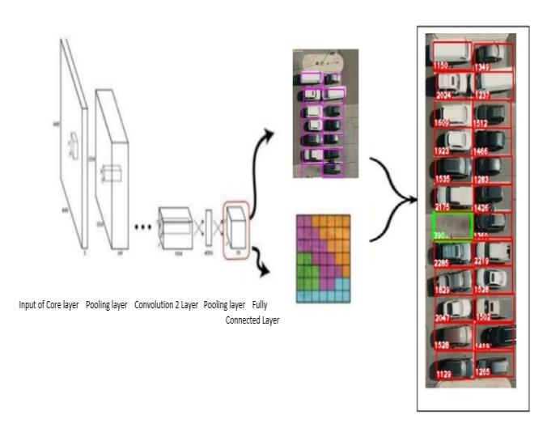

Figure 2 vehicle detection process

In another article, CRNN (Convolutional Recurrent Neural Network), a well-validated classifier in time-series analysis, is chosen as the common classifier to assess various time-frequency features and their improved versions for object counting and F0 estimation [4].

Another study introduces a straightforward approach to spatially and temporally condition trajectories. They combine this representation with a learned object descriptor to accomplish motion segmentation for the constituent motions, yielding positive results, as illustrated in Figure 3.

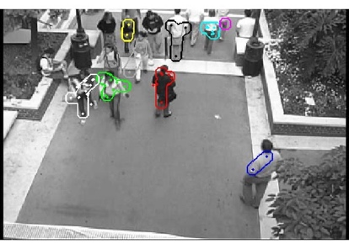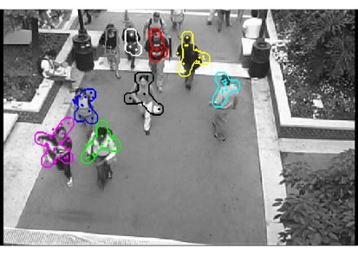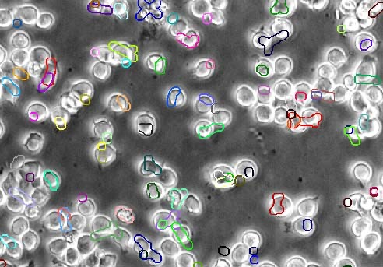

Figure 3 Counting Crowded Moving Objects results

There are many application beyond these, which shows the object detection is really useful and practical. By referring them, we can propose our general solution in figure 4:

Figure 4 Proposed solution process

**4.2 Proposed solution for image obtaining.**

How to obtain stock images or videos? Again, image processing.

Several mature algorithms are available for implementation, such as SURF, which is applied in Panorama Image Stitching. In one article [6], a panorama image stitching system is proposed, featuring a combination of an image matching algorithm using modified SURF and an image blending algorithm. This approach yielded positive results, as demonstrated in Figure 5.

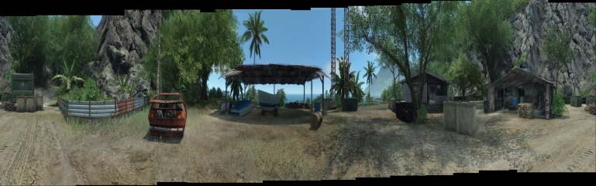

Figrue 5 Panorama stitching result.

SIFT (Scale-Invariant Feature Transform) is another great method can also achieve this goal.

So, we can easily get the raw data like figure6 shows.

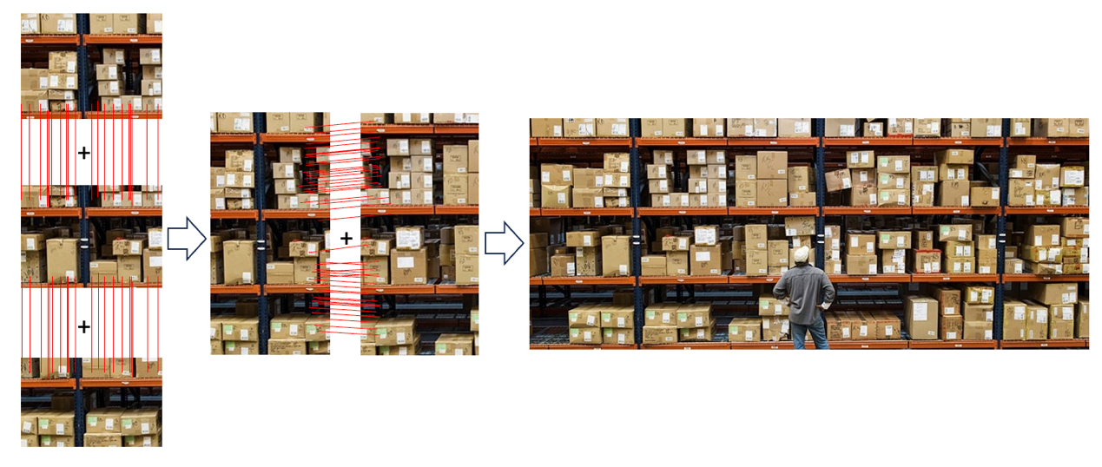

Figure 6 Proposed Panorama stitching process

And then we can input our Panorama image in our model to calculate the number of objects or do this in real time.

**4.3 The overall process**

Overall proposed process is shown in figure 7.

Figure 7 Overall proposed solution

The UAV collects **real-time data**, including pictures, position, and battery status, and compresses this data before transmitting it to the control center. Simultaneously, the UAV stores the data in **its onboard storage**. The control center is responsible for **image stitching** and **object counting**, as previously mentioned. Therefore, the primary role of the **UAV is navigation and data collection**. Now, let's discuss the UAV design.

**5.Platform Choice**

In line with our mission requirements, the selection of a suitable platform for our autonomous stock counting UAV system is of utmost importance. The choice of platform is critical to ensure that the system can efficiently and effectively meet the specified objectives.

|  |  |  |  |  |
| --- | --- | --- | --- | --- |
| **Aspect** | **Quadcopter** | **Hexacopter** | **Hybrid UAVs** | **Bladeless/Tough UAVs** |
| **Outlook** | Aerial Quadcopter Drone Black | Smyths Toys UK | dbpower x600c |  |  |
| **Flight Configuration** | **Four rotors** | **Six rotors** | **Variable (multirotor and fixed-wing)** | **Ducted fans or enclosed rotors** |
| **Maximum Take-Off** | **Typically < 3 kg** | **Typically < 5 kg** | **Varies (typically > 3 kg)** | **Typically < 5 kg** |
| **Autonomous Flight** | **Yes** | **Yes** | **Yes** | **Yes** |
| **Vertical Take-Off and Landing (VTOL)** | **Yes** | **Yes** | **Yes (with transition)** | **Yes** |
| **Fixed-Wing Flight** | **No** | **No** | **Yes** | **No** |
| **Flight Range** | **Limited (typically < 30 min)** | **Moderate (typically 30-60 min)** | **Extended (depends on design)** | **Moderate (typically 30-60 min)** |
| **Energy Efficiency** | **Moderate** | **Moderate** | **Efficient in fixed-wing mode** | **Efficient (depends on design)** |
| **Maneuverability** | **Good** | **Good** | **Multirotor: Good;**  **Fixed-wing: Limited** | **Good** |
| **Payload Capacity** | **Limited (typically < 2 kg)** | **Moderate (typically 2-5 kg)** | **Varies (typically > 2 kg)** | **Limited (typically < 2 kg)** |
| **Noise Level** | **Moderate** | **Moderate** | **Variable (multirotor and fixed-wing)** | **Low (typically quieter)** |
| **Safety (Rotor Exposure)** | **Exposed Rotors** | **Exposed Rotors** | **Exposed (multirotor); Enclosed (fixed-wing)** | **Enclosed Rotors** |
| **Cost** | **Generally Lower** | **Moderate** | **Moderate to High** | **Moderate to High** |
| **Complexity** | **Lower** | **Moderate** | **Moderate to High** | **Moderate to High** |

**Table 3 Normal platform comparations**

**Recommended Platform: Quadcopter**

Considering mission requirements, size, weight, payload, power source, flight time, and other factors, a quadcopter platform is recommended for the autonomous stock counting UAV system. Quadcopters offer stability and agility for indoor operations, compact design for manoeuvrability in narrow aisles, adequate payload capacity, and simplicity in operation. This choice aligns with system requirements and will be detailed further in subsequent sections of this report.

**6. Component selection**

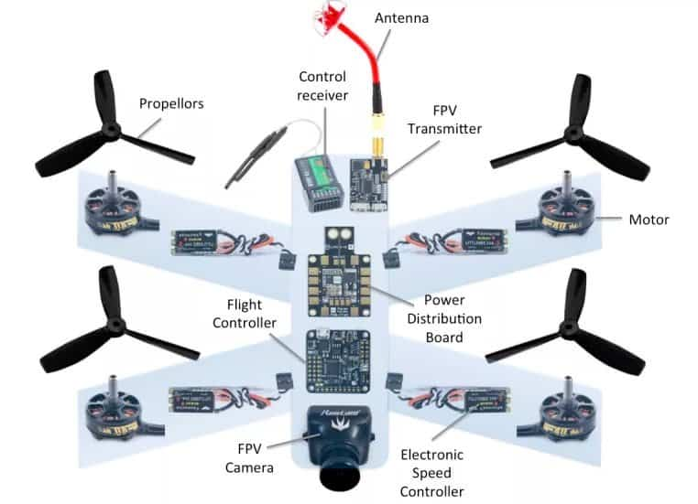

Figure 8 Structure of proposed Quadcopter

For the UAV, as figure 8 shows, a variety of sensors and hardware devices are necessary, including MCUs (Microcontroller Units), image processors, communication modules, and more. In this section, I will research these devices and provide a general overview.

**6.1 MCU**

The MCU serves as the core for UAV control, integrating attitude sensors for attitude control and processing position information from GPS and image sensors to plan paths to specific locations. For this project, I propose two choices: STM32F4 series MCUs based on ARM Cortex-M4 and Field Programmable Gate Arrays (FPGA).

**STM32F4 Series MCU (ARM Cortex-M4)**

* Pros: Suitable for real-time control, extensive library support, good power efficiency, and various connectivity options.
* Cons: May require additional hardware for image processing and communication.

**FPGA**

* Pros: Flexible hardware design, shortened development time, lower development cost, and the ability to design custom functions.
* Cons: Higher chip cost compared to standard MCUs.

FPGAs offer the advantage of easily designing image processing accelerators to significantly improve efficiency. Open-source MCU cores like Cortex series are readily available and can be embedded with other sensors. In my view, if the development team is experienced in FPGA development, FPGA should be the primary choice. Otherwise, the STM32 series is the recommended option.

### **6.2 Image sensor**

Camera plays a very crucial role in my design. I compare several normal camera and select high quality camera like ArduCam camera module or Raspberry Pi SEN022 Official Camera Module even though they are much more expensive than normal cameras.

Table 4 Camera comparation

|  |  |  |  |
| --- | --- | --- | --- |
|  | Raspberry Pi SEN022 Official Camera Module | [ArduCam Camera Module](https://www.amazon.sg/Arducam-IMX327-STARVIS-Sensitivity-Raspberry/dp/B0BWRQB3KW/ref=sr_1_6?adgrpid=152961809988&hvadid=641392356958&hvdev=c&hvlocphy=9062542&hvnetw=g&hvqmt=e&hvrand=11151953502718664984&hvtargid=kwd-849087350599&hydadcr=11261_330496&keywords=arducam+camera+module&qid=1696597323&sr=8-6) | Camera Module OV7670 |
| Outlook | Image result for Raspberry Pi Sen022 Official Camera Module. Size: 175 x 185. Source: thepihut.com | Arducam 2MP IMX327 Color Ultra Low Light STARVIS WDR Camera Module with M12 Lens, High NIR Sensitivity Camera for Raspberry P | Camera Module OV7670 |
| Price | S$45 | S$50 | S$10 |
| Parameters | Supports 1080p 30 720p 60 | Maximum frame rate in Full HD 1080p mode: 30 fps. | 640 x 480 15fps |
| Advantages | 8 megapixel Sony IMX219 image sensor | Ultra Low Light: is capable of high G Sensitivity, high NIR sensitivity, Cost-Effective | Power Operation: 60mW / 15fps |

### **6.3 Motor selection**

Certainly, here are some specific motor options that you can consider for a drone project with a maximum take-off weight of less than 3 kg, suitable for autonomous stock counting in a warehouse.

Brushless Motor Generic DYS BE1806 is one of the good choice.

|  |  |
| --- | --- |
|  | KV: 2300 Stator Diameter: 23mm Stator Length: 18.5mm Shaft Diameter: 2.0mm Motor Dimensions(Diameter*Len): Φ23×18.5mm Weight (g): 18g No.of Cells(Lipo): 2-3S Max Continuous current(A): 7.6A Max Continuous Power(W): 84.4W |

Figure 9 Selected motor

### **6.4 Communication Module**

In the typical scenario, Wi-Fi and Bluetooth are common technologies, but in our project, where the aisle length is only 80 meters, Bluetooth can be considered for onboard communication. However, it may not provide stable connections over longer distances and can be obstructed by obstacles.

Therefore, I recommend the use of Cellular Modems (4G/5G), which offer greater stability and support higher data rates. Additionally, there are numerous IoT cellular modems available that are cost-effective and easy to implement. Furthermore, with the ongoing development of cellular networks, we can anticipate future improvements in performance and cost reductions.

Figure 10 4G/5G cellular module

### **6.5 Battery**

**Lithium-Ion (Li-ion) Batteries:**

Safer and more stable than LiPo batteries, longer lifespan, and less prone to swelling. Li-ion batteries are often used in consumer drones and some professional applications.

Slightly lower energy density and discharge rates compared to LiPo batteries.

The same, there are some other choice but this option is good enough to this design.

### **6.6 Other sensors**

**IMU:** It Contains **Accelerometer**, **Gyroscope** and **Magnetometer. They can provide the information of position and orientation.**

**LiDAR (Light Detection and Ranging):** LiDAR can provide obstacle detection and avoidance capabilities within the warehouse. It depends, we need this module if the SLAM algorism need it.

**Optical Flow Sensors:** Optical flow sensors use cameras to track ground movement. They are useful for maintaining position when GPS signals are weak or unavailable, such as when flying indoors.

**Voltage and Current Sensors:** These sensors help monitor the UAV's power system, including battery voltage and current draw, to prevent over-discharge and ensure safe operation

**Data Storge:** CF card is needed to save the flight data and collected data during flight.

**6.7 Hardware choice and Power Consumption**

In conclusion, I chose the following Table 5.

Table 5 Selected Modules information

|  |  |  |  |
| --- | --- | --- | --- |
| Module | Module name | Power | Weight |
| MCU | STM32F4XX | 50 mW-500mW | 0.05kg |
| Communication | Cellular module  Bluetooth module | 0.5 W-5W | 0.02kg |
| Image sensor | ArduCam Camera Module | 200 mW-250 mW | 0.05kg |
| Motor | Generic DYS BE1806 | 50W * 4 | 0.1kg |
| Battery | Lithium-Ion (Li-ion) | - | 0.3-0.4kg |
| Other sensors | IMU, CF card, sensors etc. | - | 0.1kg |
| Other materials | Lines, fans, PCB board etc. | - | 0.1kg |
| Total | - | ≈210W | ≈1kg |

The total power consumption is 200-250W, the endurance of UAV is around 30 minutes by calculation. This result satisfy the requirement of this project.

**7. Autonomous Flight Control**

In order to control the UAV we need control the four motors and control the position and orientation of UAV. The general control structure is shown in Figure 11.

Figure 11 Flight control structure

We have two main approaches to do the flight dynamic modelling.

**7.1 UAV Flight Dynamics Modeling**

7.1.1 First-Principles Modeling Approach  
The first-principles modeling approach involves developing a mathematical model based on fundamental physical laws and principles that govern the system's behavior. First-principles models are typically derived from physical laws, such as Newton's laws of motion or conservation principles.

7.1.2 System Identification Approach  
The system identification approach involves collecting data from the UAV and using statistical techniques to identify the system's behavior and dynamics. This approach is particularly useful when the system's dynamics are complex or difficult to model analytically. By analyzing the collected data, you can derive a mathematical model that represents the UAV's behavior and use it for control design and optimization.

Step1: Model structure determination

Step2: Data collection and pre-processing.

Step3: Unknown parameter identification.

Step4: Model validation.

7.1.3 Selected Approach  
In the development of an autonomous UAV system for warehouse stock counting, a combination of both approaches can be advantageous. First-principles modeling can capture the fundamental dynamics of the UAV, including its flight behavior and payload capacity. System identification can then refine and enhance the model using real-world data obtained during flight tests.

Reference [7] presents a grey box method, while [8] proposes a model-data hybrid approach comprising two steps:

1. Establishing a baseline model using first principles.
2. Enhancing the model through online identification.

The baseline model includes a linearized state equation with adjustable parameters. These parameters are continuously optimized through a least-squares identification algorithm using real-time flight data.

**7.2 Flight Control**

When we get the dynamic model, next we need do the flight control based on the dynamic model. The general control structure is shown in Figure 12

Figure 12 Control structure

Classical control: PID control, developed in 1940s and utilized heavily for in industrial processes. Examples: everywhere in life...

Optimal control: Linear quadratic regulator (LQR), H2 optimal control, Kalman filter etc.

Figure 13 Structure of quadrotor flight control

Figure 14 Inner loop command generator

Actuator command generator

Inner-loop controller

Outer-loop controller

Reference [9] An adaptive flight control theory, based on dynamic inversion and linear neural network, is introduced to the control of the UAV. A Sigma-Pi neural network is introduced to eliminate the inverse error adaptively to improve the robustness of the controller.

By using flight control, we can achieve the trajectory following, position and orientation control. Next we need to know how to flight and what’s the trajectory.

**8. GPS-less Navigation**

**8.1 General idea of solution**

Navigation is the primary challenge in this design in my view, and to achieve full automation, creating a highly accurate 3D model of the warehouse is essential. Computer vision technology plays a crucial role in this process, capitalizing on its computational power and hardware capabilities.

To attain precise distance measurement and build the 3D model, object detection, recognition, and visual odometry are necessary. Equipping the UAV with an automatic avoidance mechanism enhances safety.

However, total automation of the process can be complex. Therefore, I propose a semi-automatic flight approach for 3D model construction. Initially, the operator controls the UAV's flight within the warehouse using a remote controller. The central control computer generates an ideal 3D model of the warehouse, and once this is achieved, the computer generates an optimal trajectory based on the 3D model to be sent to the UAV for tracking.

**8.2 The technology**

**8.2.1 Visual Odometry**

Implement visual odometry algorithms that use the onboard camera to estimate the UAV's position and orientation relative to its surroundings.

Utilize the recognition of barcode landmarks to improve visual odometry accuracy. There are a lot related researches and method can be used. Such as “Self-Supervised Learning of Visual Odometry”  this article[10] introduced a new self-supervised visual odometry model. The model uses continuous binocular images and optical flow for training, and can achieve monocular testing

**8.2.2 Object Detection and Recognition**

Utilize computer vision algorithms to detect and recognize barcodes on the cargo racks.

The UAV Obstacle Avoidance. The article “A Survey of Indoor UAV Obstacle Avoidance Research”[11] gives us a general idea of how

This technology develop recently and show some solutions based on normal sensors or camera independently.

**8.2.3 Simultaneous Localization and Mapping (SLAM)**

Without GPS, SLAM is a viable choice to achieve the project's objectives. One article [12] introduces a novel algorithm that uses OpenCV ArUco markers as a reference for path detection and guidance through a stereo camera. This technology enables the drone to navigate and map its environment using vision-based path planning, with an emphasis on guidance robustness, accurate vehicle pose estimation, and real-time operation. The algorithm's performance is assessed in a 3D simulated environment with ROS and Gazebo.

Additionally, another article [13] presents an autonomous system that guides a low-cost quadcopter using an on-board computer, sensors, and a ground station. It employs a spatially consistent probabilistic model for navigation and 3D mapping.

**8.2.4 Fusion Algorithms**

Sensor fusion algorithms, including Kalman filters and sensor fusion play a critical role in combining data from multiple sensors to achieve accurate UAV pose estimation and improve SLAM accuracy.

**9. Conclusion**

I have completed the entire drone design process, which encompasses the following steps:

1. The operator monitors the drone's flight in the warehouse and sends the data to the central control computer.
2. The central control computer constructs a 3D model of the warehouse.
3. The central control computer generates the optimal flight trajectory.
4. The drone autonomously follows the trajectory while performing obstacle avoidance.
5. The drone transmits real-time data back to the central control computer.
6. The central control computer applies object detection algorithms and performs counting.
7. The central control computer generates a positional table for all detected objects and overlays points on the images

Table 6 Detection results

|  |  |  |
| --- | --- | --- |
| Object number | Position | Created time |
| 1 | (x, y, z) | XX:XX:XX |
| 2 | (x, y, z) | XX:XX:XX |

8. Operator can sample and check the results of detection.

In summary, the central control computer primarily handles the complex calculations, utilizing models such as machine learning, to accomplish tasks like building a 3D warehouse model, generating optimal trajectories, and object detection. The quadcopter serves as an actuator to collect data in the warehouse and relay real-time information to the central control computer. This design maximizes model flexibility and simplifies maintenance and updates. Crucially, the results are easily verifiable and auditable in the end.

**Reference**

[1] G. M. Cidal, Y. A. Cimbek, G. Karahan, Ö. E. Böler, Ö. Özkardesler and H. Üvet, "A Study on the Development of Semi Automated Warehouse Stock Counting System," 2019 6th International Conference on Electrical and Electronics Engineering (ICEEE), Istanbul, Turkey, 2019, pp. 323-326, doi: 10.1109/ICEEE2019.2019.00069.

[2] Chow, Harry KH, et al. "Design of a RFID case-based resource management system for warehouse operations." Expert systems with applications 30.4 (2006): 561-576.

[3] D. Kalpanadevi, K. Kartheeban, M. Mayilvaganan and P. Bamaruckmani, "Computer Vision- Hybrid Learning based on Multi Scale Dilated Convolution Module Mechanism Implemented for Object Detection," 2022 International Conference on Automation, Computing and Renewable Systems (ICACRS), Pudukkottai, India, 2022, pp. 1208-1211, doi: 10.1109/ICACRS55517.2022.10029040.

[4] L. Li, S. Song, L. Wang, L. Ye, Y. Jing and G. Pang, "Feature Evaluation for Underwater Acoustic Object Counting and F0 Estimation," 2022 4th International Conference on Robotics and Computer Vision (ICRCV), Wuhan, China, 2022, pp. 180-185, doi: 10.1109/ICRCV55858.2022.9953234.

[5] V. Rabaud and S. Belongie, "Counting Crowded Moving Objects," 2006 IEEE Computer Society Conference on Computer Vision and Pattern Recognition (CVPR'06), New York, NY, USA, 2006, pp. 705-711, doi: 10.1109/CVPR.2006.92.

[6]L. Juan and G. Oubong, "SURF applied in panorama image stitching," 2010 2nd International Conference on Image Processing Theory, Tools and Applications, Paris, France, 2010, pp. 495-499, doi: 10.1109/IPTA.2010.5586723.

[6] M. A. Jamil, M. Ahsan, M. J. Ahsan and M. A. Choudhry, "Time domain system identification of longitudinal dynamics of a UAV: A grey box approach," 2015 International Conference on Emerging Technologies (ICET), Peshawar, Pakistan, 2015, pp. 1-6, doi: 10.1109/ICET.2015.7389200.

[7] Y. Huang, X. Xiang, H. Zhou, D. Tang and Y. Chang, "Refinement of UAV dynamics model through online identification: a model-data hybrid approach," 2020 Chinese Automation Congress (CAC), Shanghai, China, 2020, pp. 5161-5166, doi: 10.1109/CAC51589.2020.9327807.

[8]Q. Lin, Z. Cai, Y. Wang, J. Yang and L. Chen, "Adaptive Flight Control Design for Quadrotor UAV Based on Dynamic Inversion and Neural Networks," 2013 Third International Conference on Instrumentation, Measurement, Computer, Communication and Control, Shenyang, China, 2013, pp. 1461-1466, doi: 10.1109/IMCCC.2013.326.

[9]L. Song and W. Luo, "Self-Supervised Learning of Visual Odometry," 2020 International Conference on Information Science, Parallel and Distributed Systems (ISPDS), Xi'an, China, 2020, pp. 5-9, doi: 10.1109/ISPDS51347.2020.00009.

[10]J. Li, X. Xiong, Y. Yan and Y. Yang, "A Survey of Indoor UAV Obstacle Avoidance Research," in IEEE Access, vol. 11, pp. 51861-51891, 2023, doi: 10.1109/ACCESS.2023.3262668.

[11]M. Irfan, S. Dalai, K. Kishore, S. Singh and S. A. Akbar, "Vision-based Guidance and Navigation for Autonomous MAV in Indoor Environment," 2020 11th International Conference on Computing, Communication and Networking Technologies (ICCCNT), Kharagpur, India, 2020, pp. 1-5, doi: 10.1109/ICCCNT49239.2020.9225398.

[12] S. Anandharaman, M. Sudhakaran and R. Seyezhai, "A low-cost visual navigation and mapping system for Unmanned Aerial Vehicle using LSD-SLAM algorithm," 2016 Online International Conference on Green Engineering and Technologies (IC-GET), Coimbatore, India, 2016, pp. 1-6, doi: 10.1109/GET.2016.7916802.